**Assignment**

**By: Osama Anwer**

**Roll No. 341696**

Q.1: Create two integer variables length and breadth and assign values then check if they are square values or rectangle values. ie: if both values are equal then it's square otherwise rectangle.

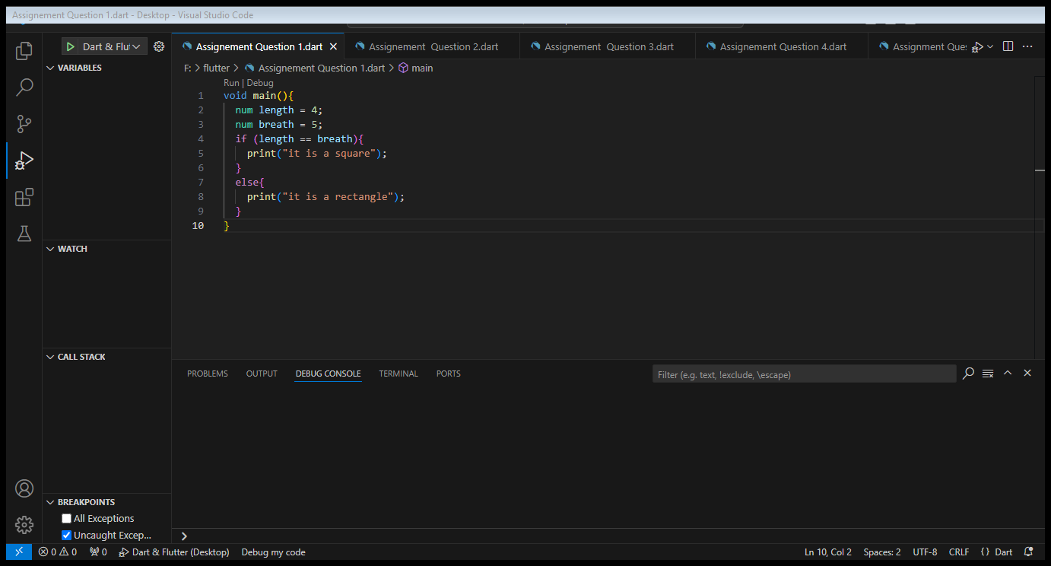

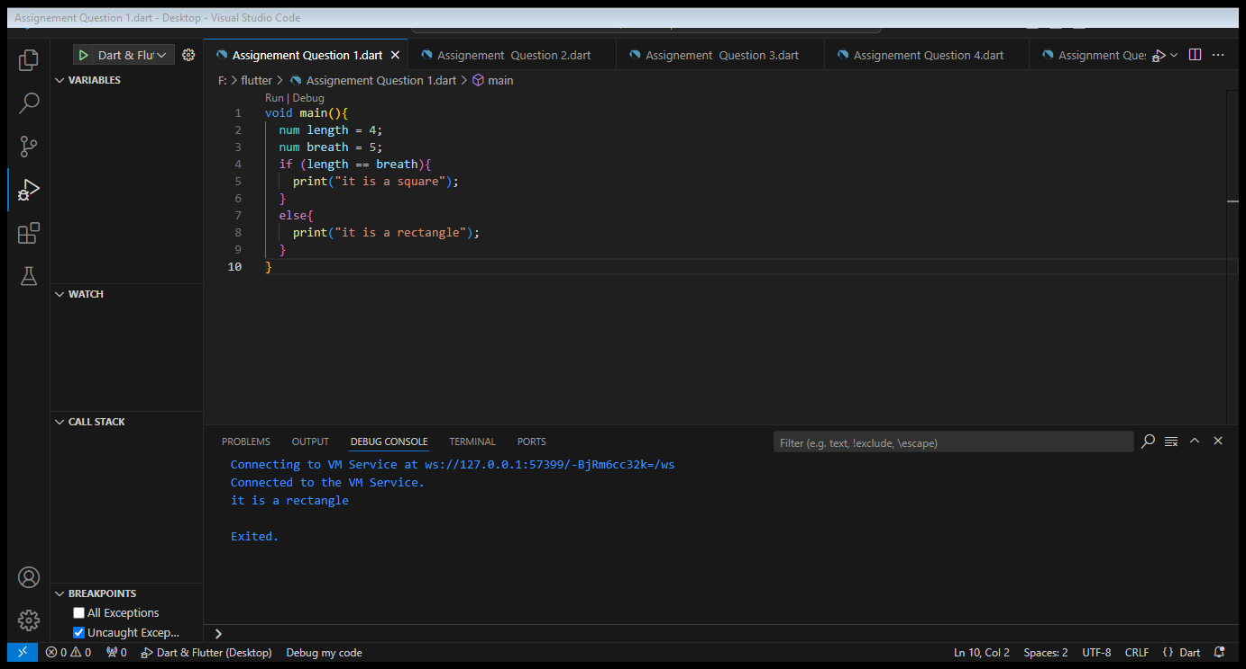

Q.2: Take two variables and store age then using if/else condition to determine oldest and youngest among them.

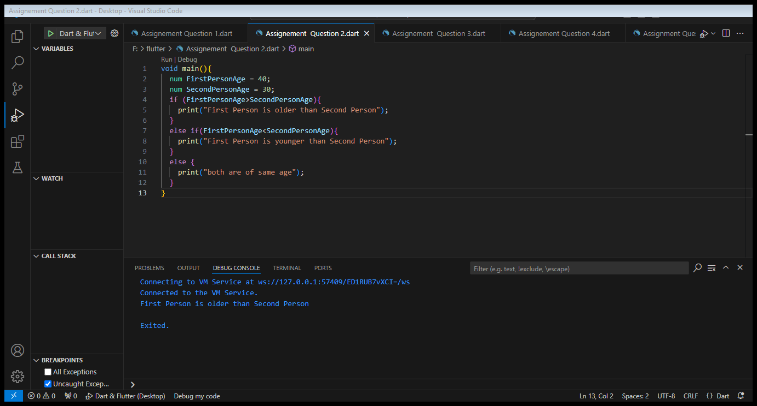



Q.3: A student will not be allowed to sit in exam if his/her attendance is less than 75%. Create integer variables and assign value: Number of classes held = 16, Number of classes attended = 10, and print percentage of class attended. Is student is allowed to sit in exam or not?

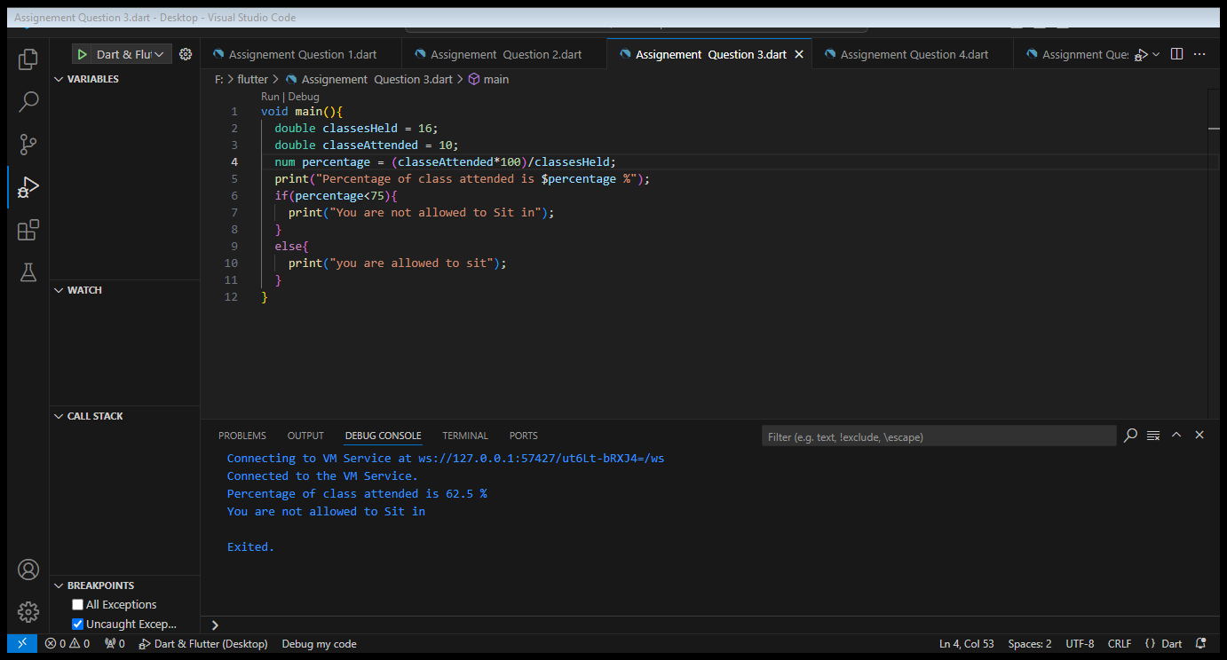



Q4: Write a program to convert Celsius to Fahrenheit . i.e: Temperature in degrees Fahrenheit (°F) = (Temperature in degrees Celsius (°C) * 9/5) + 32

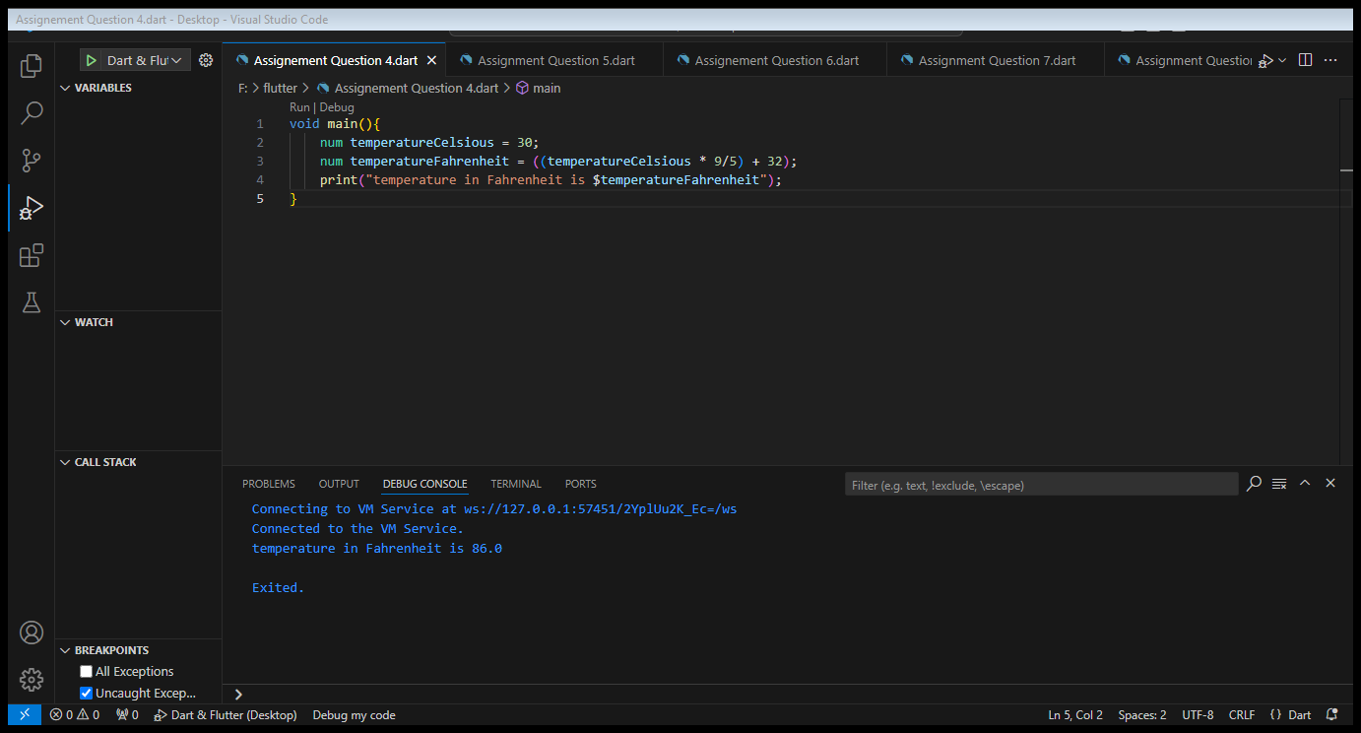



Q.5 Write a program to read temperature in centigrade and display a suitable message according to temperature: You have num variable temperature = 42; Now print the message according to temperature: temp < 0 then Freezing weather temp 0-10 then Very Cold weather temp 10-20 then Cold weather temp 20-30 then Normal in Temp temp 30-40 then Its Hot temp >=40 then Its Very Hot

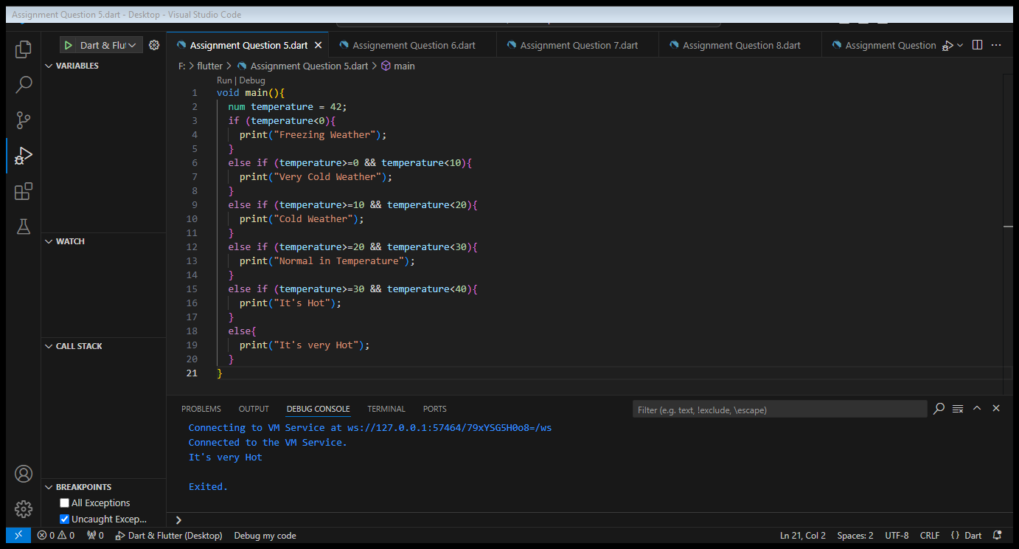

Q.6: Write a program to check whether an alphabet is a vowel or consonant.

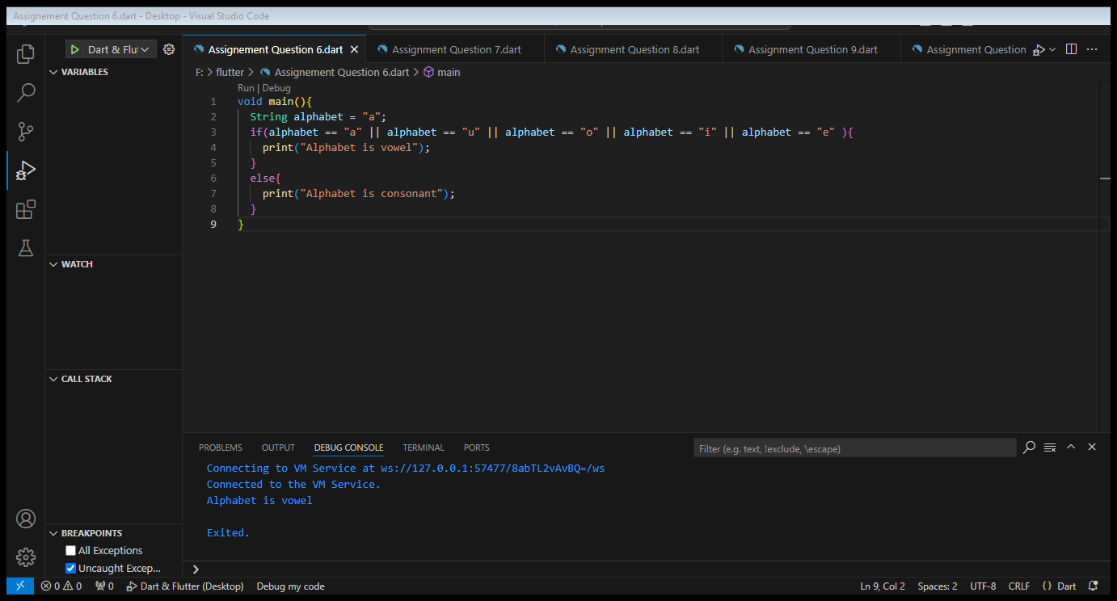



Q7: Create a marksheet using operators of at least 5 subjects and output should have Student Name, Student Roll Number, Class, Percentage, Grade Obtained etc. i.e: Percentage should be rounded upto 2 decimal places only.

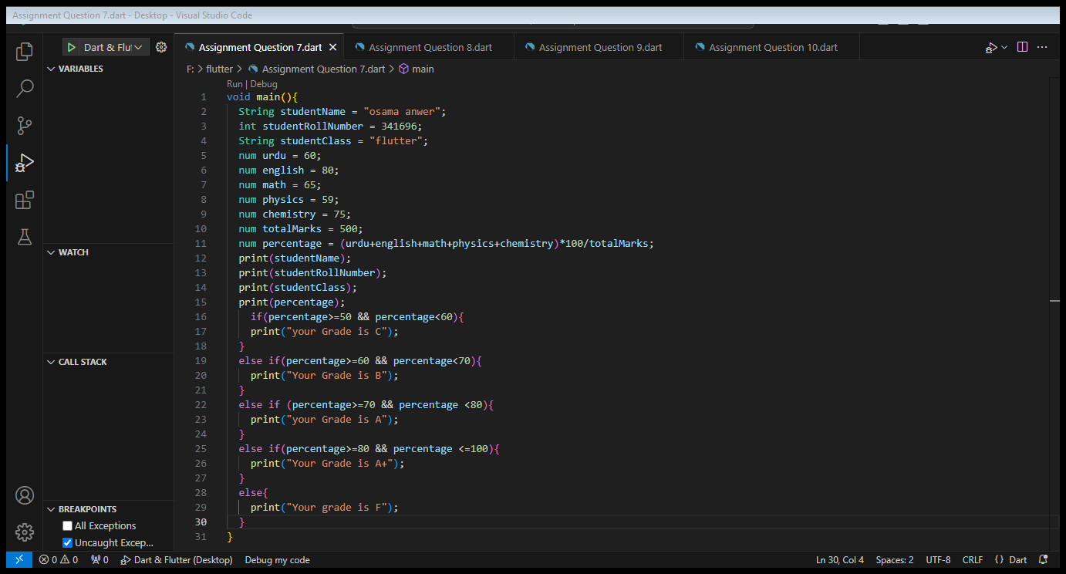

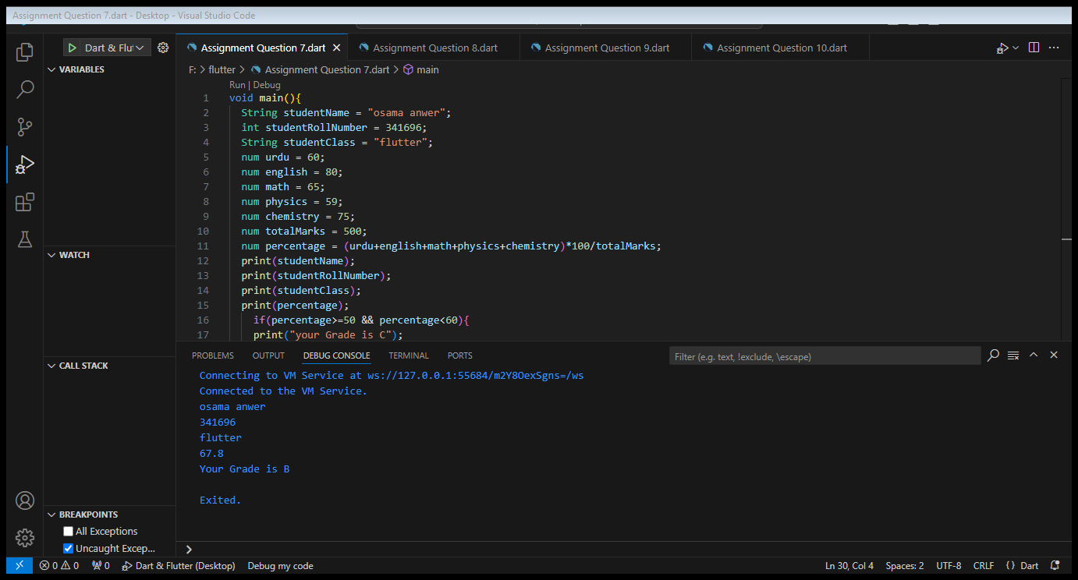

Q8: Check if the number is even or odd? i.e : Even numbers are completely divisible by 2. (2,4,6,8,10,….)

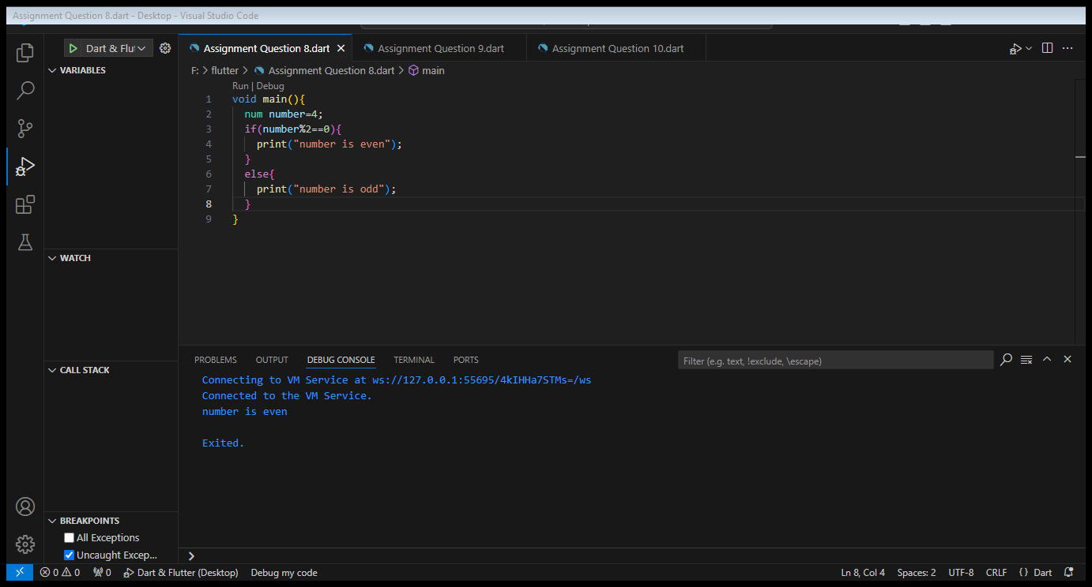



Q9: Check if a number is even then check if its divisible by 5 or not & if a number is odd then check if its divisible by 7 or not.

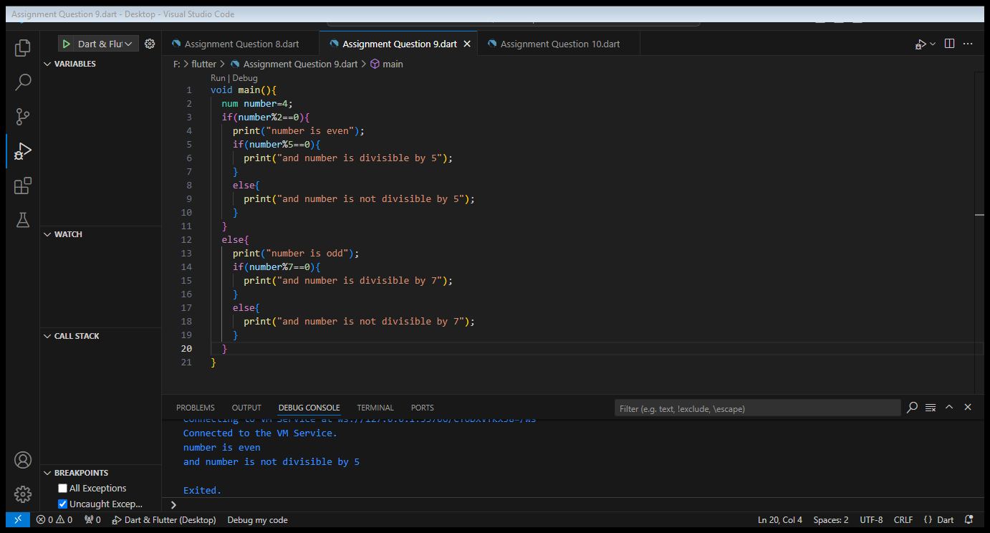



Q10: Write a program that takes three numbers from the user and prints the greatest number & lowest number

